Programming Practice Chapter 10
Program 10-1
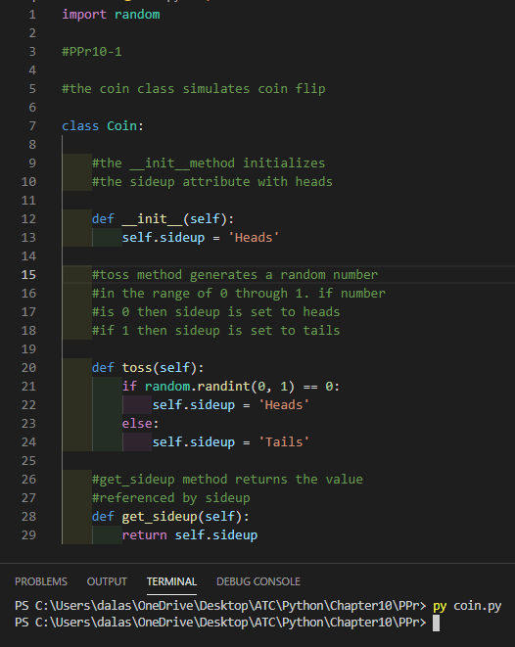

Program 10-2
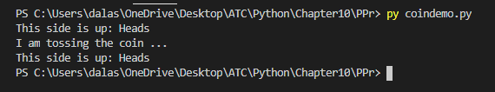

Program 10-7
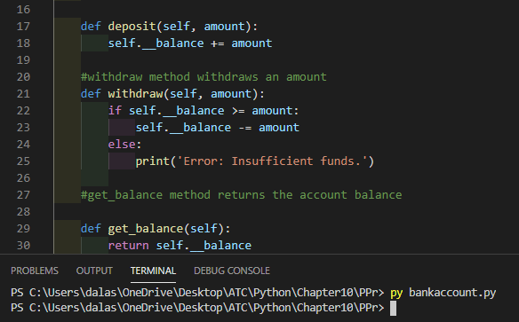

Program 10-8
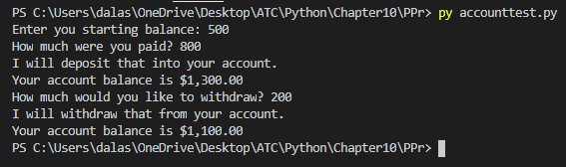

Program 10-9
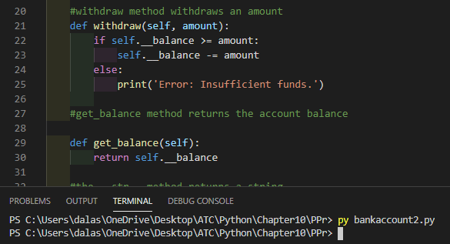

Program 10-10
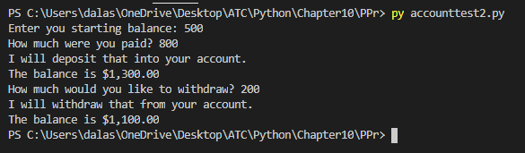

Program 10-12
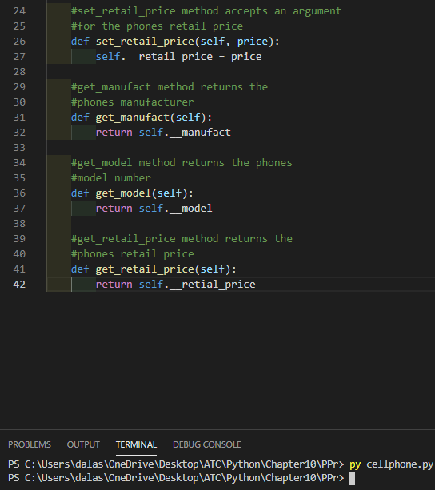

Program 10-13
